Prompt:
We are in the process of developing an e-commerce based software application.
We want the customers be able to buy the products listed on the software application.
We are in phase of gathering functional requirements and finalising the functional requirements.
You can act as a business analyst and suggest a list of functional requirements for our software application.
You can suggest 10 most popular features.

Chat GPT:

Below is a detailed functional breakdown of the “Product Details Page (PDP)”, written from a business analyst perspective, suitable for requirement documentation or BRD/FRD.

Product Details Page – Functional Requirements
1. Product Information Display
The system shall display complete product information, including:
- Product name
- Product SKU / unique identifier
- Product brand or manufacturer
- Short description and detailed description
- Product category and sub-category
- Product price (original price, discounted price if applicable)
- Tax information (if required by region)
- Stock availability status (In Stock / Out of Stock / Limited Stock)
Business Rule:
- If a product is out of stock, the “Add to Cart” button shall be disabled.

2. Product Images & Media
The system shall allow:
- Display of multiple product images
- Image zoom functionality
- Thumbnail navigation
- Optional video or 360° product view (if available)
Business Rule:
- The primary image shall be displayed by default.
- Images must be optimized for fast loading.

3. Product Variants & Options
The system shall support:
- Selection of product variants such as:
  - Size
  - Color
  - Material
  - Storage capacity (for electronics)
- Dynamic price update based on selected variant
- Variant-specific stock availability
Business Rule:
- A user must select all mandatory variants before adding the product to cart.

4. Pricing & Promotions
The system shall display:
- Current selling price
- Original price (if discounted)
- Discount percentage or amount
- Applicable offers, coupons, or promotions
Business Rule:
- Promotions shall be applied automatically if eligibility criteria are met.

5. Add to Cart & Buy Now Actions
The system shall provide:
- “Add to Cart” button
- “Buy Now” button (directs user to checkout)
- Quantity selector with minimum and maximum limits
Business Rule:
- Quantity cannot exceed available stock.
- Default quantity shall be set to 1.

6. Delivery & Shipping Information
The system shall allow customers to:
- Check delivery availability by entering a postal/ZIP code
- View estimated delivery date
- View shipping charges (if applicable)
- View delivery restrictions (if any)
Business Rule:
- Delivery estimates shall be location-based.

7. Product Ratings & Reviews
The system shall display:
- Average product rating
- Total number of reviews
- Customer reviews with ratings, comments, and dates
The system shall allow:
- Logged-in customers to submit reviews after purchase
Business Rule:
- Only verified purchasers may submit reviews (recommended).

8. Product Specifications & Attributes
The system shall display:
- Structured product specifications (e.g., dimensions, weight, material, warranty)
- Technical attributes in a tabular format
Business Rule:
- Specifications shall be configurable by product category.

9. Related & Recommended Products
The system shall display:
- Similar products
- Frequently bought together items
- Recently viewed products
Business Rule:
- Recommendations may be rule-based or algorithm-driven.

10. Return, Refund & Warranty Information
The system shall display:
- Return policy summary
- Refund eligibility
- Warranty details (if applicable)
Business Rule:
- Return eligibility shall be based on product category and seller policy.

11. SEO & Accessibility (Functional Considerations)
The system shall:
- Use SEO-friendly URLs for product pages
- Display meta title and description
- Support accessibility features (alt text for images, keyboard navigation)

12. Error & Edge Case Handling
The system shall:
- Display a friendly message if the product is unavailable or removed
- Redirect to a relevant page if product ID is invalid

Deliverable Formats (Optional)
If you want, I can convert this into:
- FRD-ready “The system shall…” statements
- User stories + acceptance criteria
- Wireframe-level feature checklist
- API-level functional expectations
Just let me know your preferred format and documentation depth.

GOOGLE GEMINI:
It’s an exciting stage to be in! As a Business Analyst, my goal is to bridge the gap between your business vision and the technical execution. For an e-commerce platform to be successful in today’s market, it needs to balance a frictionless user experience with robust back-end management.
Here are the 10 most popular and essential functional requirements for your e-commerce application:
1. User Authentication and Profile Management
Users must be able to create accounts, log in, and manage their personal data.
- Requirements: Support for email/password registration and Social Auth (Google, Apple, Facebook).
- Functionality: Users should be able to manage saved addresses, payment methods, and view their order history.
2. Advanced Product Search and Filtering
To prevent "search fatigue," users need to find exactly what they want within seconds.
- Requirements: A search bar with auto-suggestions and "fuzzy logic" (to handle typos).
- Functionality: Filters for category, price range, brand, ratings, and attributes (size, color).
3. Dynamic Product Catalog
This is the heart of the store, where the product's value is communicated.
- Requirements: Support for high-resolution images, video demonstrations, and detailed descriptions.
- Functionality: Real-time "In Stock/Out of Stock" indicators and a "Wishlist" feature for saving items for later.
4. Shopping Cart and Persistence
The cart should act as a temporary holding area that stays consistent across devices.
- Requirements: Users can add, remove, or update quantities of items.
- Functionality: The system must calculate sub-totals, taxes, and shipping estimates in real-time before checkout.
5. Secure Checkout and Payment Gateway Integration
A multi-step or single-page checkout that feels secure and easy.
- Requirements: Integration with providers like Stripe, PayPal, or Square.
- Functionality: Support for credit/debit cards, digital wallets, and "Buy Now, Pay Later" (BNPL) options.
6. Order Management and Tracking
Once a purchase is made, the transparency of the delivery process defines the customer experience.
- Requirements: Automated order confirmation emails/SMS.
- Functionality: A real-time tracking dashboard showing the order status (Processing, Shipped, Out for Delivery, Delivered).
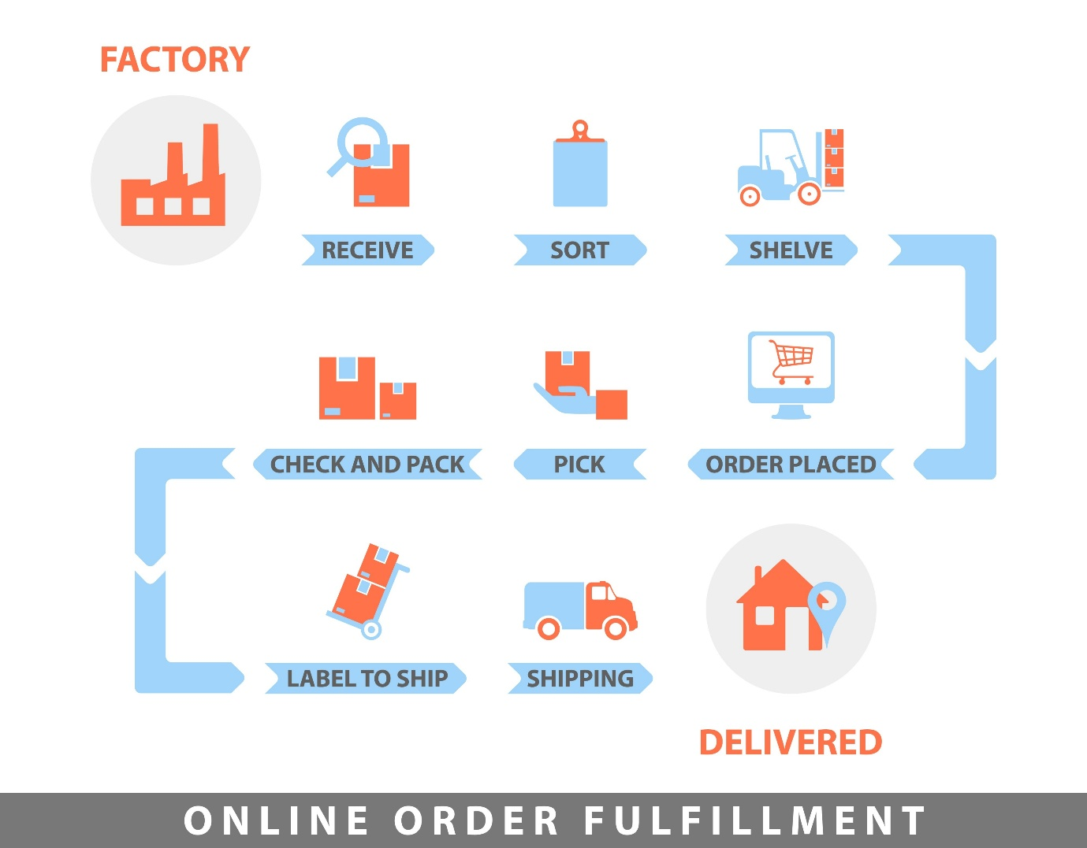
Shutterstock
7. Ratings and Reviews System
Social proof is the strongest driver of conversions in e-commerce.
- Requirements: Only verified purchasers should be allowed to leave a star rating and text review.
- Functionality: Ability for users to upload photos of the received product within their review.
8. Promotions and Discount Engine
Marketing teams need the ability to drive sales through incentives.
- Requirements: A field at checkout for promo codes.
- Functionality: Support for automatic discounts (e.g., "Buy One Get One Free" or "Free Shipping over $50").
9. Inventory and Admin Dashboard
The back-end must allow your team to manage the store without writing code.
- Requirements: A secure admin panel to add/edit products and manage stock levels.
- Functionality: Low-stock alerts sent to administrators when an item falls below a certain threshold.
10. Returns and Refund Management
A clear return policy handled through the app increases buyer confidence.
- Requirements: An automated "Request Return" button within the user’s order history.
- Functionality: Generation of return shipping labels and tracking of refund status.

Comparison of Key User Roles
Feature | Customer Capability | Admin/Staff Capability
Orders | Place and track orders | Fulfill, cancel, or refund orders
Products | Browse and review | Add, hide, or edit pricing
Profile | Manage personal data | Manage user permissions/bans

Would you like me to draft a more detailed User Story for any of these features (e.g., the Checkout Process) to help your developers understand the specific logic required?

MICROSOFT COPILOT:
Perfect timing—you’re at one of the most critical phases of building an e-commerce application. As a business analyst, I’ll outline 10 core functional requirements that are considered essential for modern e-commerce platforms. These features balance customer experience, operational efficiency, and scalability.

🔑 Top 10 Functional Requirements for Your E-Commerce Application
1. User Registration & Authentication
- Secure sign-up/login via email, phone, or social accounts.
- Password recovery and multi-factor authentication.
- Guest checkout option for faster purchases.
2. Product Catalog Management
- Ability to add, edit, and categorize products.
- Support for product descriptions, images, videos, and specifications.
- Inventory tracking with stock availability indicators.
3. Search & Filtering
- Advanced search with auto-suggestions.
- Filters by price, category, brand, ratings, etc.
- Sorting options (e.g., newest, best-selling, lowest price).
4. Shopping Cart & Wishlist
- Add/remove products easily.
- Save items for later (wishlist).
- Real-time cart updates with price totals.
5. Checkout & Payment Gateway Integration
- Multiple payment options (credit/debit cards, UPI, wallets, net banking).
- Secure payment processing with PCI-DSS compliance.
- Support for discounts, promo codes, and gift cards.
6. Order Management
- Order confirmation, tracking, and history.
- Ability to cancel or modify orders before shipping.
- Automated invoice generation.
7. Shipping & Delivery Management
- Integration with logistics partners.
- Real-time delivery tracking.
- Multiple shipping options (standard, express, same-day).
8. Customer Account Dashboard
- Profile management (addresses, payment methods).
- Order history and returns management.
- Personalized recommendations based on browsing/purchase history.
9. Ratings & Reviews
- Customers can rate products and leave feedback.
- Moderation tools to prevent spam or inappropriate content.
- Display average ratings and verified purchase badges.
10. Admin Panel & Analytics
- Role-based access for admins, sellers, and support staff.
- Sales reports, customer insights, and inventory analytics.
- Tools for managing promotions, banners, and featured products.

📊 Bonus Features (Optional but Highly Valuable)
- Push Notifications & Email Alerts (order updates, promotions).
- Chatbot/Customer Support Integration (live chat, FAQs).
- Multi-language & Multi-currency Support (for global reach).
- Personalized Recommendations powered by AI.

👉 These 10 features form the backbone of most successful e-commerce applications. Once you finalize them, you can prioritize based on your target market and budget.
Would you like me to also suggest a requirements traceability matrix (RTM) so you can map these features to business goals and test cases? That’s often the next step in requirement gathering.

PERPLEXITY AI:
Here is a list of 10 most popular and essential functional requirements for an e-commerce software application, written from a business analyst’s perspective to help finalize your requirements document.futurismtechnologies+2​
1. User Registration & Profile Management
Customers should be able to create an account using email, phone, or social login, and manage their profile (name, contact details, addresses, password).elogic+1​
Guest checkout should also be supported so users can buy without creating an account.elogic+1​
2. Product Catalog & Search
The system must display a structured product catalog with categories, subcategories, and filters (price, brand, ratings, attributes like size/color).solutions.trustradius+1​
Customers should be able to search products by keyword, sort by relevance, price, or popularity, and view detailed product pages (images, description, price, stock status, reviews).salesfire+1​
3. Shopping Cart
Users must be able to add/remove items, update quantities, and see the cart summary (subtotal, taxes, discounts, total) in real time.futurismtechnologies+1​
The cart should persist across sessions (for logged-in users) and support saving items for later.elogic+1​
4. Secure Checkout Flow
A multi-step checkout process should guide the user through: shipping address, delivery method, payment method, and order review.elogic+1​
The system must support both guest and logged-in checkout, with clear progress indicators and the ability to edit details before final payment.elogic+1​
5. Multiple Payment Options
The application should integrate with popular payment gateways (credit/debit cards, UPI, net banking, wallets like Paytm/PhonePe, and later options like EMI or BNPL).solutions.trustradius+1​
Payment processing must be secure (PCI-DSS compliant), with clear success/failure messages and automatic order status updates.futurismtechnologies+1​
6. Order Management
Customers should be able to view their order history, current orders, order status (placed, confirmed, shipped, delivered, cancelled), and download invoices.solutions.trustradius+1​
Admin/staff should be able to manage orders (update status, cancel, refund, generate invoices, and track shipments).futurismtechnologies+1​
7. Inventory & Stock Management
The system must track real-time stock levels for each product and variant (size, color, etc.).solutions.trustradius+1​
When stock is low or out of stock, the product should be shown as “Out of Stock” or “Only X left” and prevent checkout if stock is zero.futurismtechnologies+1​
8. Shipping & Delivery Management
The application should support multiple shipping methods (standard, express, same-day) with configurable rates based on location, weight, or order value.elogic+1​
Customers should see estimated delivery dates and be able to track their order using a tracking ID from the courier.solutions.trustradius+1​
9. Promotions & Discounts
The system should support various promotional features:
- Coupon codes and promo codes (percentage or fixed-amount discounts)salesfire+1​
- Automatic discounts (e.g., “Buy 1 Get 1 Free”, bulk discounts)salesfire+1​
- Special offers on categories, products, or for specific user segments (new users, loyal customers)salesfire+1​
10. Customer Support & Communication
Customers should be able to contact support via multiple channels (email, phone, chat, or in-app chatbot).avidclan+1​
The system should send automated notifications (order confirmation, shipping updates, delivery, and post-purchase feedback requests) via email and SMS.elogic+1​

Optional but Highly Recommended (for later phases)
Once the core 10 are implemented, consider adding:
- Wishlist / Save for laterappinventiv+1​
- Product reviews and ratingsmiquido+1​
- Personalized recommendations (based on browsing/purchase history)avidclan+1​
- Return & refund management (RMA process)futurismtechnologies+1​
- Multi-vendor marketplace support (if planning to onboard third-party sellers)miquido+1​
If you share your target audience (B2C, B2B, or marketplace) and tech stack (web, mobile app, or both), I can refine this list further with more specific requirements and priority levels.elogic+1​
- https://www.futurismtechnologies.com/blog/top-10-key-features-of-e-commerce-software/
- https://elogic.co/blog/how-to-write-an-ecommerce-website-requirements-specification-document-tips-tricks-and-best-practices/
- https://solutions.trustradius.com/buyer-blog/top-features-ecommerce-software/
- https://elogic.co/blog/functional-and-non-functional-requirements-for-ecommerce-websites/
- https://www.avidclan.com/blog/top-features-every-e-commerce-websites-and-mobile-apps-should-have-in-2025/
- https://www.salesfire.co.uk/articles/functional-requirements-for-ecommerce-website/
- https://appinventiv.com/blog/ecommerce-app-features-for-startups-and-enterprises/
- https://dashdevs.com/blog/how-to-write-good-software-requirements-specification-for-your-mobile-application/
- https://www.miquido.com/blog/ecommerce-app-features/
- https://www.scribd.com/document/768488800/question-bank-for-business-analyst

